Welcome to the Taulbee Salary Survey (2025)!

The Taulbee Salary Survey is a critical source of data on computing academic salaries and doctoral student tuition & stipends. The information you provide will be used to produce the annual Taulbee Survey Report, which is a key resource for academic leaders, policymakers, and other stakeholders.

This survey collects comprehensive data on:

Computing academic salaries.

Computing doctoral student tuition & stipends.

Your academic unit's contribution to this year's survey is vital to the accuracy and value of this data for the computing community at large, so we thank you for agreeing to participate this year.

Please answer each question as accurately as possible. The survey is designed so you can save your progress and return to it later by returning to the link you received via email.

This survey's deadline is December 17, 2025 at 11:59pm ET. This link will automatically expire once the deadline passes and any partial data entered will be saved.

If you have any questions, please contact the CRA Taulbee team at TaulbeeSurvey@cra.org.

Background & Compliance Information

Background: CRA conducts several activities that support its members and the overall computing sector, e.g., providing professional development resources, informing policy makers and the public on matters that foster growth of computing research, and distributing facts and data of interest to the computing research community. The Taulbee Survey, which CRA has performed annually since 1974, has earned prominence as a carefully-structured and reliable source of industry data that is crafted with applicable safeguards. Each year a wide array of respondents choose to reply to the Taulbee survey, knowing that robust data enhances the validity of results and bolsters the survey’s value to its full spectrum of users.
Invitation: CRA invites you to contribute to the computing community’s valuable common knowledge base by completing the enclosed 2025 Taulbee survey form according to your institution’s parameters for participation in such initiatives.
Compliance: CRA is committed to complying fully with applicable laws and regulations that protect privacy, equality, competition, and other pertinent standards. CRA seeks to protect the survey’s many legitimate purposes by expecting universal commitment to such standards. CRA, a third-party survey administrator, takes due precautions to adhere to laws and ethical principles, such as:

maintaining strict confidentiality of all submitted data, which shall not be disclosed in raw form to anyone;

engaging a professional survey service to receive and process all data independently;

soliciting historical salary data by position; and

distributing in the Taulbee survey results (and any related report, publication, or presentation) only data that is aggregate, anonymous, and inclusive of numerous respondents in order to preclude identification of any individual data source.

CRA encourages community members to engage actively with your institution’s resources, as appropriate, to complete the Taulbee Salary Survey (2025) toward yielding widespread benefits for the global computing community.

Section A. Preliminary Questions

The purpose of this section is to ask a few preliminary questions that will allow us to tailor the rest of the survey to your academic unit. Your answers here will directly determine which subsequent questions you are presented with, saving you time and ensuring you only provide the data that is relevant to your unit's structure.
Please note all questions in this section are required. Your cooperation in answering these questions is greatly appreciated, and it will ensure a more efficient and customized survey experience.

How will you be reporting faculty salaries in this survey?*
( ) Individual salaries
( ) Summary salary data
Validation: Must be numeric, whole numbers only, positive numbers only

Department Size. Please provide the total number of full-time (FTE) faculty by role in your academic unit as of July 2025.*
Count only faculty engaged in computing, e.g., in an EECS program, omit faculty who are EE-only, if separable. In the comments section, please let us know anything specific about the roles you are reporting in each category. Please exclude visiting lecturers from the FTE counts.
Total FTE
Full Professors
Associate Professors
Assistant Professors
Teaching Professors
Other Instructors
Researchers
Postdoctorates
Other Faculty

Comments:
______________________________________________________________________________________________________________________________________________________________________________________________________________________________________________________________________________________________________________________________________________________________________________________________________

To customize the survey for your academic unit, please check all full-time faculty roles for which you will be reporting salaries based on the definitions from this guide.*
Please note that this will customize the questions you will be asked in the survey. For instance, if you do not have postdoctorates in your academic unit and you select that you will not be reporting on them, you will not receive questions related to postdoctorates salaries.
[ ] Full Professors
[ ] Associate Professors
[ ] Assistant Professors
[ ] Teaching Professors
[ ] Other Instructors
[ ] Researchers
[ ] Postdoctorates

Will your academic unit be reporting on adjunct rates in this survey?*
( ) Yes
( ) No
Logic: Hidden unless: "Will your academic unit be reporting on adjunct rates in this survey?" is one of the following answers ("Yes")

For which of the following adjunct types will your academic unit be reporting per-course rates?*
( ) Adjuncts with their highest degree being an MS
( ) Adjuncts with their highest degree being a PhD

Which types of doctoral students will you be reporting stipends for in this survey? Check all that apply. Please reference the definition guide for these categories.*
Your academic unit's answer to this question will customize the stipend question for doctoral students you will be asked in the survey.
[ ] Teaching Assistants
[ ] Research Assistants
[ ] Full-Support Fellows
[ ] Graduate Assistants for Computer Systems Support

Which types of doctoral students will you be reporting tuition rates (net cost to student after support per academic year, assuming full-time status) for in this survey? Check all that apply. Please reference the definition guide for these categories.*
Your academic unit's answer to this question will customize the tuition rates question for doctoral students you will be asked in the survey.
[ ] Teaching Assistants
[ ] Research Assistants
[ ] Full-Support Fellows
[ ] Graduate Assistants for Computer Systems Support
[ ] Self-Funded

For each type of doctoral student at your academic unit, please select all of the tuition rate options that apply.*
This will customize the questions asked related to tuition rates charged to doctoral students in section D.
 | In-state/  in-country | Out of state/  out of country | One rate  (no in/out difference) | Other
Teaching Assistants | [ ] | [ ] | [ ] | [ ]
Research Assistants | [ ] | [ ] | [ ] | [ ]
Full-Support Fellows | [ ] | [ ] | [ ] | [ ]
Graduate Assistants for Computer Systems Support | [ ] | [ ] | [ ] | [ ]
Self-Funded | [ ] | [ ] | [ ] | [ ]

Section A1. Unionization of Faculty

Which full-time faculty roles in your academic unit that you are providing salary data for are unionized as of fall 2025?
 | Unionized | Not Unionized | Data Not Available
Full Professors | ( ) | ( ) | ( )
Associate Professors | ( ) | ( ) | ( )
Assistant Professors | ( ) | ( ) | ( )
Teaching Professors | ( ) | ( ) | ( )
Other Instructors | ( ) | ( ) | ( )
Researchers | ( ) | ( ) | ( )
Postdoctorates | ( ) | ( ) | ( )

Do you have any comments about the unionization of full-time faculty within your academic unit?
________________________________________________________________________________________________________________________________________________________________________________________________________________________________________________________________________________________________________________________

Page logic: This page will show when "How will you be reporting faculty salaries in this survey?" is "Individual salaries"

Section B. Full-Time Faculty Salaries (Individual-Level)

Individual-level salary data from must be uploaded from the spreadsheet template provided here.
Include only full-time, regular-status salaries (e.g., omit phased retirement, negotiated reduction, occasional adjuncts, etc.). If a faculty member is shared between departments, include them if they are 50% or more in your department. Provide the entire salary, not just the portion funded by your department. Enter numbers that represent actual salaries for actual faculty (not salary ranges). Include pay supplements associated with teaching and research; do not include administrative supplements or summer support.
Use salaries effective July 10, 2025.
United States academic units should provide 9-month salary in US dollars.
Canadian academic units should provide 12-month salary in Canadian dollars.
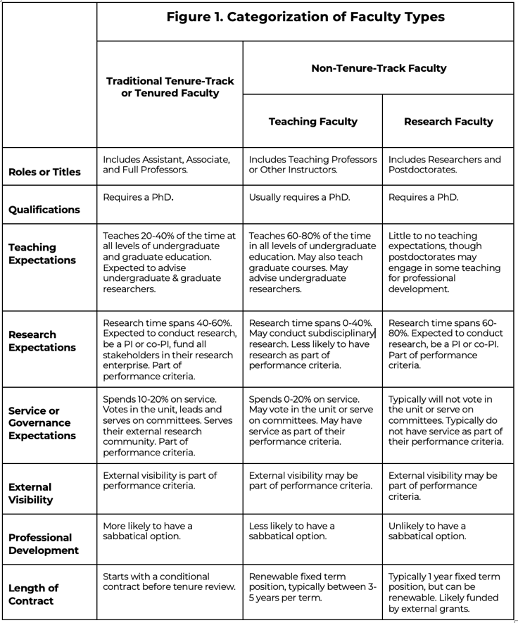

Validation: Accepts 1 file. Allowed types: xlsx, csv. Max file size: 500 KB.

Please upload your spreadsheet for individual-level salaries. Download the template here.
Upload file here.

Comments:

________________________________________________________________________________________________________________________________________________________________________________________________________________________________________________________________________________________________________________________

Page logic: This page will show when "How will you be reporting faculty salaries in this survey?" is ("Summary salary data")

Section B. Full-Time Faculty Salaries (Summary)

Include only full-time, regular-status salaries (e.g., omit phased retirement, negotiated reduction, occasional adjuncts, etc.). If a faculty member is shared between departments, include them if they are 50% or more in your department. Provide the entire salary, not just the portion funded by your department. Enter numbers that represent actual salaries for actual faculty (not salary ranges). Include pay supplements associated with teaching and research; do not include administrative supplements or summer support.
Use salaries effective July 10, 2025.
United States academic units should provide 9-month salary in US dollars.
Canadian academic units should provide 12-month salary in Canadian dollars.

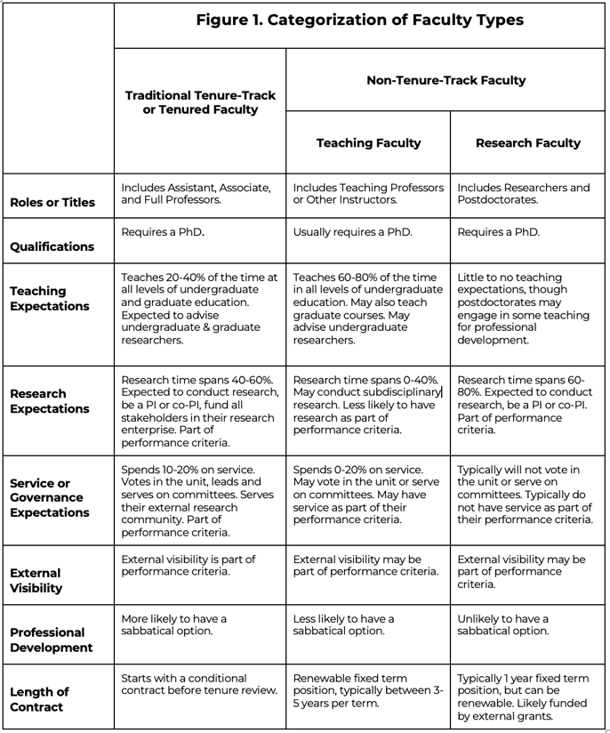

Traditional Tenure-Track or Tenured Faculty

Traditional Tenure-Track or Tenured Faculty include the roles of Assistant Professors, Associate Professors, and Full Professors. These roles require the individual to hold a PhD. The expectations of these roles include teaching, research, and service or governance. Their research expectations make up about 40-60% of their time. They are expected to apply for and receive grant funding for research projects to sustain their academic research within the institution. Research is a part of their performance criteria. They are also expected to advise undergraduate and graduate researchers. Their teaching expectations make up 20-40% of their time, and they are expected to teach at all levels of undergraduate and graduate education. Finally, their service/governance expectations make up the remaining 10-20% of their time. They vote within their academic unit, lead and serve on committees, and serve their external research community. Service is a part of their performance criteria.
Validation: Must be numeric, whole numbers only, positive numbers only
Logic: Hidden unless “To customize the survey for your academic unit, please check all full-time faculty roles for which you will be reporting salaries…" is one of the following answers ("Assistant Professors")

Academic-year salaries for full-time: Assistant Professors
Taulbee defines Assistant Professors as the first rank in the series of tenure-track professorial stages that are typical for traditional tenure-track faculty. Assistant Professors are usually hired on a conditional basis for a set number of years, usually anywhere between 5-9 years, before they go up for their tenure review process. As above, their roles consist traditionally of 40-20-20, meaning 40% of their time is typically dedicated to research, 20% to teaching undergraduate and graduate courses at the institution, and 20% to service and governance within committees and their academic unit, though this ratio may vary.
 | Number in Role | Mean (Average) Salary
Any years in rank

Validation: Must be numeric, whole numbers only, positive numbers only
Logic: Hidden unless “To customize the survey for your academic unit, please check all full-time faculty roles for which you will be reporting salaries…" is one of the following answers ("Associate Professors")

Academic-year salaries for full-time: Associate Professors
Taulbee defines Associate Professors as the second rank in the series of professorial stages that are typical for traditional tenured faculty. Associate Professors have usually gone through their tenure-review process and have been successfully granted tenure either within their academic unit or were hired as an Associate Professor with transferrable or negotiated transfer tenure status.
 | Number in Role | Mean (Average) Salary
In rank <=7 years
In rank 8+ years
Validation: Must be numeric, whole numbers only, positive numbers only
Logic: Hidden unless “To customize the survey for your academic unit, please check all full-time faculty roles for which you will be reporting salaries…" is one of the following answers ("Full Professors")

Academic-year salaries for full-time Full Professors

Taulbee defines Full Professors as the third rank in the series of professorial stages that are typical for traditional tenured faculty. Full Professors are typically the senior-most level of the professoriate. They are typically promoted from Associate Professors based on their performance and achievement, though this promotion process varies from institution to institution.
 | Number in Role | Mean (Average) Salary
In rank <=7 years
In rank 8-15 years
In rank 16+ years

Non-Tenure-Track Teaching Faculty

Non-Tenure-Track Teaching Faculty, often holding titles like Teaching Professor or Instructor, are academic professionals primarily focused on teaching. While they usually hold a PhD, their roles differ significantly from tenure-track positions. Their contracts are for a renewable fixed term, typically 3-5 years, and do not lead to tenure. Teaching makes up the majority of their time, typically 60-80%, and they are expected to teach at all levels of undergraduate education. They may also teach graduate courses and advise undergraduate researchers. Unlike Tenure-Track Faculty, research is generally not a core expectation and is not a formal part of their performance criteria. They are not typically expected to apply for or secure grant funding for research. They dedicate a smaller portion of their time to service, usually 0-20%. They may have the right to vote within their academic unit and serve on committees, and service may be a part of their performance criteria. Their professional development opportunities, such as sabbaticals, are less common. External visibility may also be a part of their performance criteria, depending on the institution.
Validation: Must be numeric, whole numbers only, positive numbers only
Logic: Hidden unless “To customize the survey for your academic unit, please check all full-time faculty roles for which you will be reporting salaries…" is one of the following answers ("Teaching Professors")

Academic-year salaries for full-time Teaching Professors
Taulbee defines Teaching Professors as any full-time faculty member within an academic unit whose primary responsibility is teaching. These positions are typically renewable fixed-term positions between 3-5 years in length. The responsibilities of Teaching Professors usually is 60-80% of time spent teaching with some lower degree of research and service/governance responsibilities as a faculty member of the unit.
Years in rank: Please report on Teaching Professors based on the time they have been working in that role in your unit.
 | Number in Role | Mean (Average) Salary
In rank <3 years
In rank 3-5 years
In rank 6-8 years
In rank 9+ years

Validation: Must be numeric, whole numbers only, positive numbers only
Logic: Hidden unless “To customize the survey for your academic unit, please check all full-time faculty roles for which you will be reporting salaries…" is one of the following answers ("Other Instructors")

Academic-year salaries for full-time Other Instructors

Taulbee defines Other Instructors as any full-time faculty member within an academic unit whose primary responsibility is teaching with little to no responsibilities for research and service/governance in the academic unit. Please do not report part-time adjuncts in this category.
 | Number in Role | Mean (Average) Salary
In rank <3 years
In rank 3-5 years
In rank 6-8 years
In rank 9+ years

Non-Tenure-Track Research Faculty
Validation: Must be numeric, whole numbers only, positive numbers only
Logic: Hidden unless “To customize the survey for your academic unit, please check all full-time faculty roles for which you will be reporting salaries…" is one of the following answers ("Researchers")

Academic-year salaries for full-time Researchers
Taulbee defines Researchers as Ph.D.-holding faculty whose primary role is to conduct research. These positions are typically non-tenure-track, fixed-term, and are often supported by external grants. Some common titles that could fall under Researchers include: Research Professor, Research Scientist, Research Scholar, or Principal Investigator (PI), if the role is a non-tenure track, research-only position. Their responsibilities are overwhelmingly focused on research (typically 60-80% of their time). They are generally not involved in departmental governance, committee work, or department voting.
 | Number in Role | Mean (Average) Salary
Any years in rank

Validation: Must be numeric, whole numbers only, positive numbers only
Logic: Hidden unless “To customize the survey for your academic unit, please check all full-time faculty roles for which you will be reporting salaries…" is one of the following answers ("Postdoctorates")

Academic-year salaries for full-time Postdoctorates

Taulbee defines Postdoctorates (or postdocs) as individuals who have recently completed their Ph.D. and are in a temporary, full-time research position for a fixed period. Common titles for Postdoctorates may include: Postdoctoral Fellows, Postdoctoral Researchers, Postdoctoral Associates, or Research Fellows. Their primary focus is to gain additional research experience and professional training under the supervision of a senior faculty member. Their work is almost entirely dedicated to research. They are not faculty and usually do not have formal teaching responsibilities, though they may mentor students. They typically have no service obligations and are not involved in departmental governance. Their external visibility is primarily through their research publications and presentations at conferences.
 | Number in Role | Mean (Average) Salary
Any years in rank

Section C. Adjunct Rates
Validation: Must be currency, whole numbers only, positive numbers only

Adjunct Teaching Rates. As of July 10, 2025, what was your academic unit's standard per-course dollar rate for an adjunct teaching a 3-credit semester undergraduate or graduate course or equivalent, with highest degree or MS equivalent or PhD?
If your academic unit has no single standard rate, please enter the most common rate. Canadian academic units should provide this rate in Canadian dollars.
 | Undergraduate Course | Graduate Course
With MS
With PhD

Which of the following factors affect the per-course rate paid to adjunct faculty in your academic unit? Select all that apply.
[ ] Time at your institution
[ ] Experience
[ ] Special expertise
[ ] Course type/level
[ ] Student enrollment
[ ] Other, please specify:

Section D. Doctoral Student Tuition Rates and Stipends
Validation: Must be currency, whole numbers only, positive numbers only

For Teaching Assistants under full-time status, please provide the academic-year tuition rates for each of your institution's tuition categories, which you selected in Section A. Please provide the net cost to the student after support, not the official tuition rate.
Taulbee defines a Teaching Assistant (TA) as a doctoral student or candidate matriculated in a unit's doctoral program and supported by a Teaching Assistantship offered by the academic unit or institution. Teaching Assistantships generally require the doctoral candidate to dedicate a minimum of 20 hours per week to TA responsibilities related to teaching undergraduate courses in addition to their own doctoral coursework & dissertation projects, although specific requirements may differ among institutions.
Tuition rate
In-state/In-Country
Out of state/Out of Country
One rate (no in/out difference)
Other

Validation: Must be numeric, whole numbers only, positive numbers only

For Research Assistants under full-time status, please provide the academic-year tuition rates for each of your institution's tuition categories, which you selected in Section A. Please provide the net cost to the student after support, not the official tuition rate.

Taulbee defines a Research Assistant (RA) as a doctoral student or candidate matriculated in a unit's doctoral program and supported by a Research Assistantship, typically funded by external grants awarded to a doctoral student’s research lab or supporting advisor/PI. Research Assistantships generally require the doctoral candidate to dedicate a minimum of 20 hours per week to RA responsibilities related to supporting grant or other research lab responsibilities in addition to their own doctoral coursework & dissertation projects, although specific time requirements may differ among institutions.
Tuition rate
In-state/In-Country
Out of state/Out of Country
One rate (no in/out difference)
Other

Validation: Must be numeric, whole numbers only, positive numbers only

For Full-Support Fellows under full-time status, please provide the academic-year tuition rates for each of your institution's tuition categories, which you selected in Section A. Please provide the net cost to the student after support, not the official tuition rate.

Taulbee defines a Full-Support Fellow as a doctoral student or candidate matriculated in a unit’s doctoral program and supported by an external or internal fellowship. Full-Support Fellows may still be part of a research lab and take part in the responsibilities associated with conducting research as a part of the lab, but generally conduct their own research independently under the supervision of an advisor.
Tuition rate
In-state/In-Country
Out of state/Out of Country
One rate (no in/out difference)
Other

Validation: Must be currency, whole numbers only, positive numbers only

For Self-Funded doctoral students under full-time status, please provide the academic-year tuition rates for each of your institution's tuition categories, which you selected in Section A. Please provide the official tuition rate.

Taulbee defines Self-Funded doctoral students as those that are matriculated in a unit’s doctoral program and supports their tuition independently, typically without the support of a fellowship or an external grant.
Tuition rate
In-state/In-Country
Out of state/Out of Country
One rate (no in/out difference)
Other

Doctoral Students Stipends. Provide the total (not monthly) average amount of the 2025-2026 academic-year stipend for a first-year doctoral student (amount of stipend minus any allowances for tuition, registration, and other fees, if they are included in the stipend and the student has to pay them; do not include the value of tuition waivers). Include base salary only, not signing bonuses, conference travel, or other income.
United States academic units, please provide student stipend in U.S. dollars.
Canadian academic units, please provide student stipend in Canadian dollars.

Average Stipend
Teaching Assistants
Research Assistants
Full-Support Fellows
Graduate Assistants for Computer Systems Support

Are doctoral student health insurance costs covered or subsidized in addition to their stipends as of spring 2025? Please indicate yes or no for the following types of doctoral students within your academic unit.
 | Yes | No | Data Not Available | Not Applicable
Teaching Assistants | ( ) | ( ) | ( ) | ( )
Research Assistants | ( ) | ( ) | ( ) | ( )
Graduate Assistants for Computer Systems Support | ( ) | ( ) | ( ) | ( )

Which types of doctoral student roles are unionized within your academic unit as of fall 2025?
 | Yes | No |  | Data Not Available | Not Applicable
Teaching Assistants | ( ) |  | ( ) | ( ) | ( )
Research Assistants | ( ) |  | ( ) | ( ) | ( )
Graduate Assistants for Computer Systems Support | ( ) |  | ( ) | ( ) | ( )

Thank You!

Thank you for completing the Taulbee Salary Survey (2025) on behalf of your academic unit.

The data you have provided is more than just statistics—it is a critical resource that helps our entire community understand the evolving landscape of computing research and education. Your academic unit's participation is essential for providing the insights needed to inform decision-making, support advocacy, and guide future initiatives.

We are grateful for your effort and commitment to this important work.

